Routine Invasive Strategy in Elderly Patients with Non-ST Segment Elevation Acute Myocardial Infarction: A Systematic Review and Meta-analysis of Randomized Trials

Waiel Abusnina MD¹, Qais Radaideh MD¹, Abdelrazeg HoussienMD¹, Khagendra Dahal, MD¹
1 Division of Cardiovascular Diseases, Creighton University School of Medicine, Omaha, NE, USA

Abstract

Background: Invasive treatment with coronary angiography is preferred approach for patients with non-ST elevation acute coronary syndrome (NSTE-ACS) compared to medical therapy alone. The results from the randomized clinical trials (RCT) that compared the invasive treatment strategy vs. conservative approach in the elderly (≥75 years) with NSTE-ACS has been inconsistent. Aim: To compare invasive and conservative strategies in the elderly (>75 years) with NSTE-ACS.
Methods and Results: We searched PubMed, Cochrane CENTRAL Register and ClinicalTrials.gov (inception through July 10, 2021) for RCTs comparing invasive and conservative strategies in the elderly with NSTE-ACS. We used random-effects model to calculate risk ratio (RR) with 95% confidence interval(CI). A total of 6 RCT including 2,323 patients were included in the meta-analysis. The median follow-up duration was 13.5 months. When invasive approach was compared to conservative strategy, it showed no significant reduction in all-cause mortality in patients aged ≥75 years with NSTE-ACS (RR of 0.85; 95% CI 0.70–1.04; P = 0.12; I² = 0%)(figure). There was significant decrease in the term of MI (RR 0.59; 95% CI 0.49 0.71; P < 0.00001; I² = 0%) and unplanned revascularization (RR 0.30, 95% CI 0.17-0.53, P <0.001, I² = 0%). Comparison of both strategies showed no significant difference in stroke (RR 0.84; 95% CI 0.43-1.63, P = 0.60; I² = 0%), and major bleeding (RR 0.96; 95% CI 0.36-2.55, P = 0.08; I² = 56%).
Conclusion: This meta-analysis suggests that in elderly patients (>75 years) with NSTE-ACS, an invasive strategy is superior to a conservative strategy in the reduction of MI and revascularization but no difference was noted in the mortality, bleeding, and stroke.
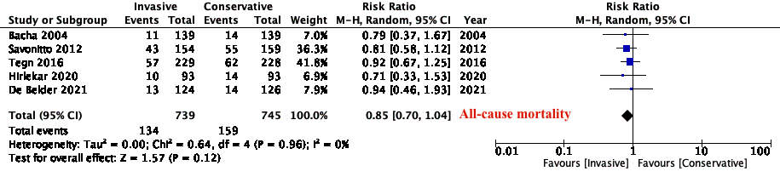

Figure: Forest plot of All-cause mortality

