Outcomes of percutaneous left atrial appendage occlusion (LAAO) on left atrial function: A systematic review and meta-analysis

Introduction:
Left atrial (LA) function has been identified as an important prognostic marker of cardiovascular disease. Recent studies have shown a direct relation between LA function and atrial fibrillation recurrence. Percutaneous LAAO has become an important therapeutic option in patients with AF, however influence of LAAO on LA function has been contentious. We performed a systematic review and meta-analysis comparing LA function before and after percutaneous LAAO.

Methods:
PubMed, Embase and Cochrane databases were searched for all studies reporting outcomes of percutaneous LAAO on left atrial function in patients with AF. Primary outcomes were peak atrial longitudinal strain (reservoir phase) measured by speckle tracking echocardiography with reference point set at QRS. Secondary outcomes included peak atrial strain (contraction phase) and LA emptying fraction. Mean difference (MD) with corresponding 95% confidence intervals (CIs) were calculated using the random-effects model.

Results:
7 studies met inclusion criteria, with a total of 267 patients, of which 175 were male. Patient were followed up for a median duration of 45 days [IQR 1-90]. There was a significant improvement in peak atrial longitudinal strain (reservoir phase) (MD 2.14 [0.32, 3.96]; p=0.02), peak atrial strain (contraction phase) (MD 2.47 [0.42, 4.52]; p=0.02), and LA emptying (MD 4.10 [0.62, 7.58]; p=0.02) in patients post percutaneous LAAO.

Conclusion:
Our meta-analysis shows significant improvement in LA function post percutaneous LAAO as measured by 2D and speckle tracking echocardiography in patients with paroxysmal atrial fibrillation.

Peak Strain (Reservoir Function)
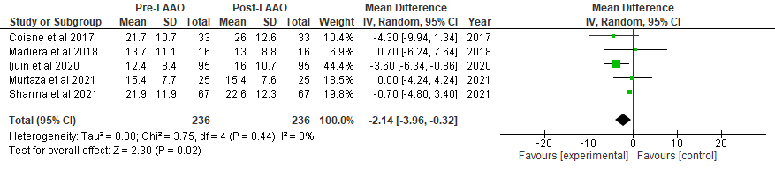

Peak Strain (Contractile Function)
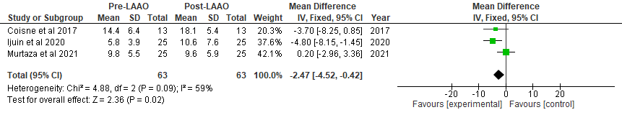

Total LA Emptying Fraction
