Cardiac Magnetic Resonance Imaging and Optical Coherence Tomography in patients with a clinical diagnosis Of Myocardial Infarction with Non-obstructive Coronary Arteries - A Systematic Review and Meta-analysis.

Background:
Myocardial Infarction with Non-Obstructive Coronary arteries (MINOCA) is defined as acute Myocardial Infarction (MI) despite the absence of severe coronary artery stenosis on angiography, and no alternative diagnosis.¹ MINOCA remains a serious diagnostic and therapeutic challenge given the various possible underlying etiologies.² Cardiac Magnetic Resonance Imaging (CMR) can distinguish between acute myocarditis (AM), MI, and Takotsubo cardiomyopathy (TCM) which are some of the commonest causes of MINOCA.³ Hence, The European Society of Cardiology recommend CMR in all MINOCA patients with an unclear etiology.⁴ Intracoronary Optical coherence tomography (OCT) is a high-resolution imaging modality that allows for assessment of the integrity of the atheroma.⁵ We aimed to study the efficacy of CMR and OCT in detecting the etiology in MINOCA patients, which has the potential to guide medical therapy.
Methods:
A systematic search was made in PubMed and Cochrane database. Search terms: Myocardial infarction, Coronary angiography, Normal coronary arteries, CMR, and OCT. Inclusion criteria were met by 18 studies. Meta-analysis was performed with 14 studies.
Results:
A total of 2474 patients were included in the meta-analysis. The mean age was 51.5 and 56.4% were men. CMR was able to establish diagnosis in 74% of the patients; 30.4% had AM, 21.3% had true MI and 12% had TCM. A diagnosis was established in 85-100% cases by incorporation of OCT with CMR, which was better at finding the etiology than CMR alone.
Conclusion:
CMR is integral in finding the cause of MINOCA. Coupling coronary OCT and CMR is better than either modality alone in detecting the etiology.

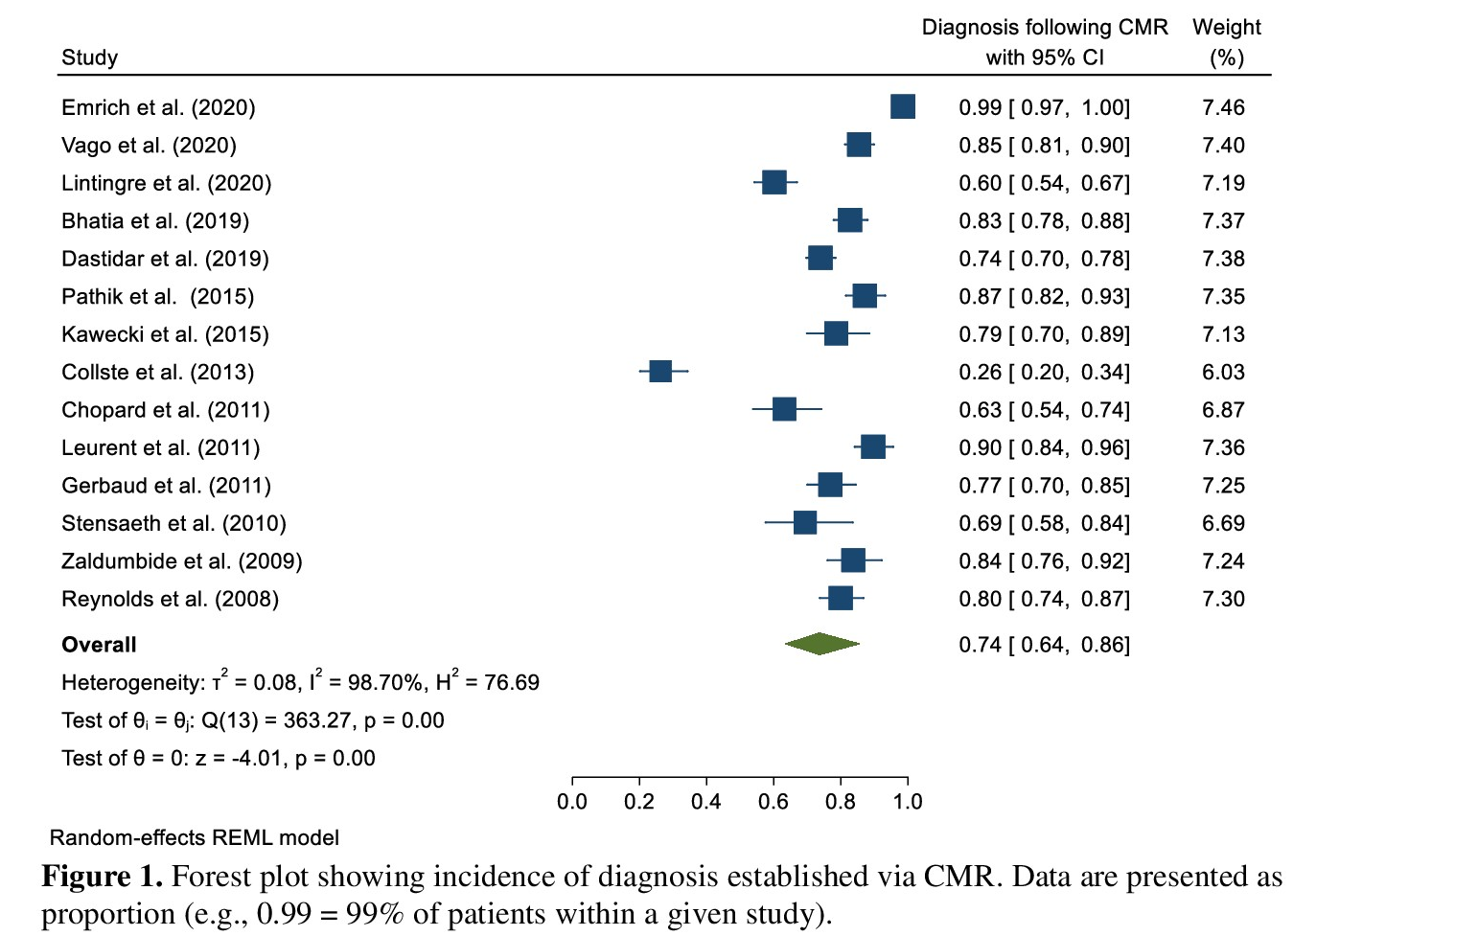

References:
1. Niccoli G, Scalone G, Crea F. Acute myocardial infarction with no obstructive coronary atherosclerosis: mechanisms and management. Eur Heart J 2015;36:475–81.
2. Mahajan N, Mehta Y, Rose M, et al. Elevated troponin level is not synonymous with myocardial infarction. Int J Cardiol 2006;111:442—9.
3. Collste O, Sorensson P, Frick M, Agewall S, Daniel M, Henareh L et al. .Myocardial infarction with normal coronary arteries is common and associated with normal findings on cardiovascular magnetic resonance imaging: results from the Stockholm Myocardial Infarction with Normal Coronaries study. J IntMed 2013;273:189–96.
4. Agewall S, Beltrame JF, Reynolds HR, Niessner A, Rosano G, Caforio AL, De Caterina R, Zimarino M, Roffi M, Kjeldsen K, Atar D, Kaski JC, Sechtem U, Tornvall P; WG on Cardiovascular Pharmacotherapy. ESC working group position paper on myocardial infarction with non-obstructive coronary arteries. Eur Heart J. 2016.
5. Tearney GJ, Regar E, Akasaka T, et al. Consensus standards for acquisition, measurement, and reporting of intravascular optical coherence tomography studies: a report from the international working group for Intravascular Optical Coherence Tomography Standardization and Validation. J Am Coll Cardiol 2012;59: 1058–72.

