Biopsy negative COVID-19 myocarditis in a heart transplant patient

Rivington, JR, Zolty R, Craig C, Anderson, D, Radio S, Stoller D

The novel coronavirus (COVID-19) has many cardiovascular manifestations including myocarditis. Endomyocardial biopsy (EMB) is the gold standard test for diagnosis of myocarditis, it will traditionally exhibit lymphocytic infiltration associated with myocyte injury in the absence of ischemia (1). However, the expected findings in patients with COVID-19 on immunosuppression have not been described. We present the case of a heart transplant patient that presented with signs and symptoms of COVID-19 along with new biventricular heart failure. Due to suspected COVID-19 myocarditis versus transplant rejection an initial EMB was performed showing no inflammation, vascular changes or myocyte damage, which is incongruent with the diagnosis of myocarditis. Due to worsening condition a repeat one was performed three weeks later that showed lymphocytic infiltrate and moderate myocardial interstitial fibrosis and focal myocytolysis suggestive of a immune response in the myocardium. Further immunofluorescence was performed which confirmed COVID specific proteins in the myocardium along with markers for thrombosis and complement activation (Figure 1). Heart transplant patients have a curbed immune response due to being on chronic immunosuppression and many studies have shown that their humoral and cell-mediated immune response to both COVID-19 and the vaccine have been altered from the general population (2,3). This case highlights the unique EMB findings of a suspected COVID-19 myocarditis transplant patient and suggests that the traditional histopathologic criteria for diagnosing myocarditis cannot be used in this special population.

References:
- Aretz HT, Billingham ME, Edwards WD, Factor SM, Fallon J, Fenoglio JJ, et al. Myocarditis. A histopathologic definition and classification. Am. J. Cardiovasc. Pathol. 1987; 1: 3–14
- Fava A, Donadeu L, Sabe N, Pernin V, Gonzalez-Costello J, Llado L, et al. SARS-CoV-2-specific serological and functional T cell immune responses during acute and early COVID-19 convalescence in solid organ transplant patients. Am J Transplant. 2021; 21(8):2749-2761.
- Peled Y, Ram E, Lavee J, Sternik L, Segev A, Wieder-Finesod A, et al. BNT162b2 vaccination in heart transplant recipients: Clinical experience and antibody response. J Heart Lung Transplant. 2021; 40(8): 759-762

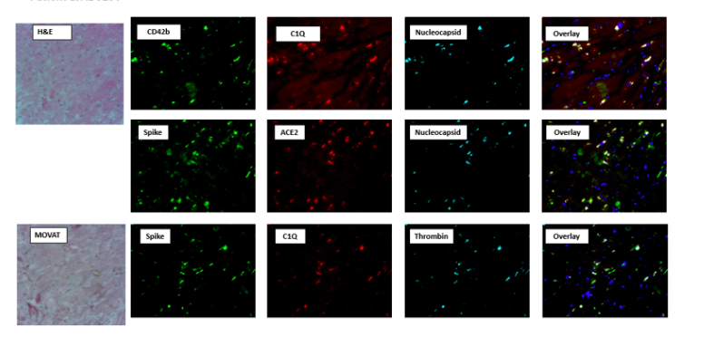

Figure 1: Immunofluorescence performed on an endomyocardial biopsy sample. Markers of prothrombotic activity (CD42b [platelets], thrombin), complement activity (C1Q) are overlayed in the far right panel with COVID-19 specific proteins (Nucleocapsid, Spike, ACE2). There is evidence of colocalization of these proteins in the myocardium.

