**Outcomes for screening diabetic patients for asymptomatic coronary artery disease (CAD) : An updated meta-analysis**

**Introduction**

Although screening for asymptomatic CAD in patients with diabetes may have enormous prognostic implications, current evidence regarding the need for pre-exercise stress testing in asymptomatic people with diabetes remains controversial. We performed a updated systematic review and meta-analysis in to compare outcomes in diabetic patients screened versus not screened for asymptomatic CAD.

**Methods:**

PubMed, Embase and Cochrane databases were searched for all studies comparing outcomes in diabetic patients who were screened versus not screened for asymptomatic CAD. Primary outcome was all-cause mortality. Secondary outcomes included cardiac death, myocardial infarction (MI), and total revascularization. Pooled odds ratios (OR) with their corresponding 95% confidence intervals were calculated using the Mantel-Haenszel random-effects model.

**Results:**

We included 7 observational studies in our meta-analysiswith a total of 7557 patients (screened group 2630, non-screened group 4927). There was no statistical difference in all cause death between the two groups. There was no statistical difference in all-cause mortality (OR 0.78 [0.56-1.07]; p=0.13), cardiac death (OR 0.77 [0.41-1.43]; p=0.41), MI (OR 0.73 [0.46-1.16]; p=0.18), or total revascularization (OR 0.73 [0.49-1.09]; p=0.12) between the two groups.

**Conclusion:**

Our meta-analysis shows no evidence to support screening diabetic patients for asymptomatic CAD

**Myocardial Infarction**

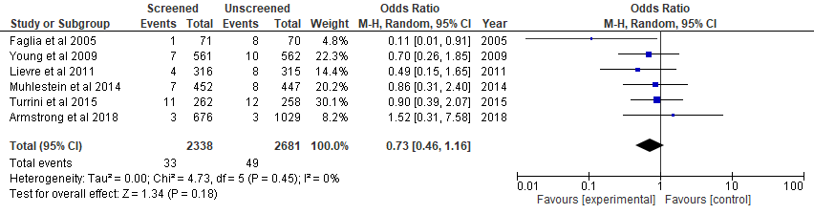

**All cause death**

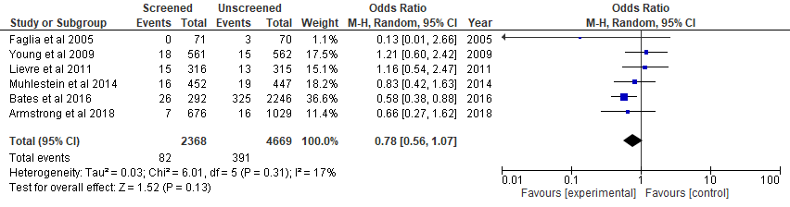

**Revascularization**

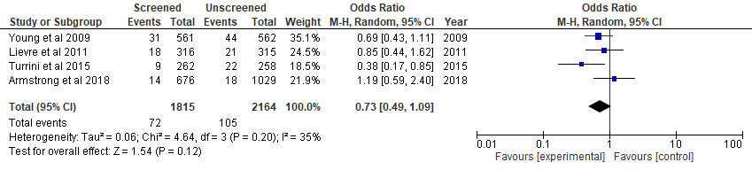

**Cardiac death**

