Shockwave Lithoplasty as the only resort to restore flow in Nonagenarian with Acute Coronary Syndrome

Qais Radaideh MD MS¹, Waiel Abusnina MD¹, Gauravpal S. Gill MBBS¹, Nagarjuna Gujjula MD¹, Ann E Narmi MD¹, Himanshu Agarwal MD¹, Toufik Mahfood Haddad MD¹

1 Division of Cardiovascular Diseases, Creighton University School of Medicine, Omaha, NE, USA

Introduction:

Among the greatest challenges in managing acute coronary syndrome are calcified lesions. Despite the availability of different atherectomy and plaque modification devices to treat these lesions, certain scenarios might prohibit the use of them. Shockwave Intravascular Lithotripsy (IVL) modifies heavily calcified lesions and offers a solution in such cases.

Method/Case
93 yr. old female with HTN and CKD presented with dyspnea and elevated hs-troponin. Echocardiogram showed EF of 45%. Early invasive strategy was pursued.
She was taken to the cath lab, which showed a culprit proximal LCx 99 % stenosis successfully treated with stenting. Attempted PTCA of mid LAD 90% lesion (a) was unsuccessful with residual waist despite multiple NC balloons due to heavy calcification (b). We attempted different scoring balloons, but they were unsuccessful crossing despite using a buddy wire. There was residual 90% stenosis but with TIMI3 flow. Hemochron ACT was more than 300 on heparin and patient was loaded with clopidogrel. Post procedure, she developed jaw pain and chest pain. EKG showed peak T waves anteriorly. Emergently, she was taken back to the cath lab, and angiography demonstrated a total occlusion of LAD (c).

Results:

After crossing lesion TIMI 3 flow was restored immediately, before ballooning, consistent with transient thrombus. Compliant balloon was used with still residual waist in the middle. There was evidence of edge dissection just proximal to the lesion (d). At this moment, we started her on GP IIB/IIIA. At the current situation, rotational or orbital atherectomy were contraindicated. Cutting or scoring balloons failed to cross the non-dilatable lesion. She was then transferred to higher level tertiary medical center. Our only option was using IVL despite not its routine use in acute MI. 3.5 x 12 mm shockwave balloon advanced crossing the lesion gradually and 4 sessions of IVL delivered. IVUS post shockwave lithotripsy showed fractured calcium in two different areas (f). Stenting was done appropriately with 3.5 by 24 mm drug eluting stent with excellent results (g). Post stent IVUS showed MSA of 9 mm2 (h).

Conclusion:

The use of intravenous lithotripsy is beneficial and safe in modifying highly calcified coronary lesions, when other modalities can’t be applied given failed lesion crossing and edge dissection.

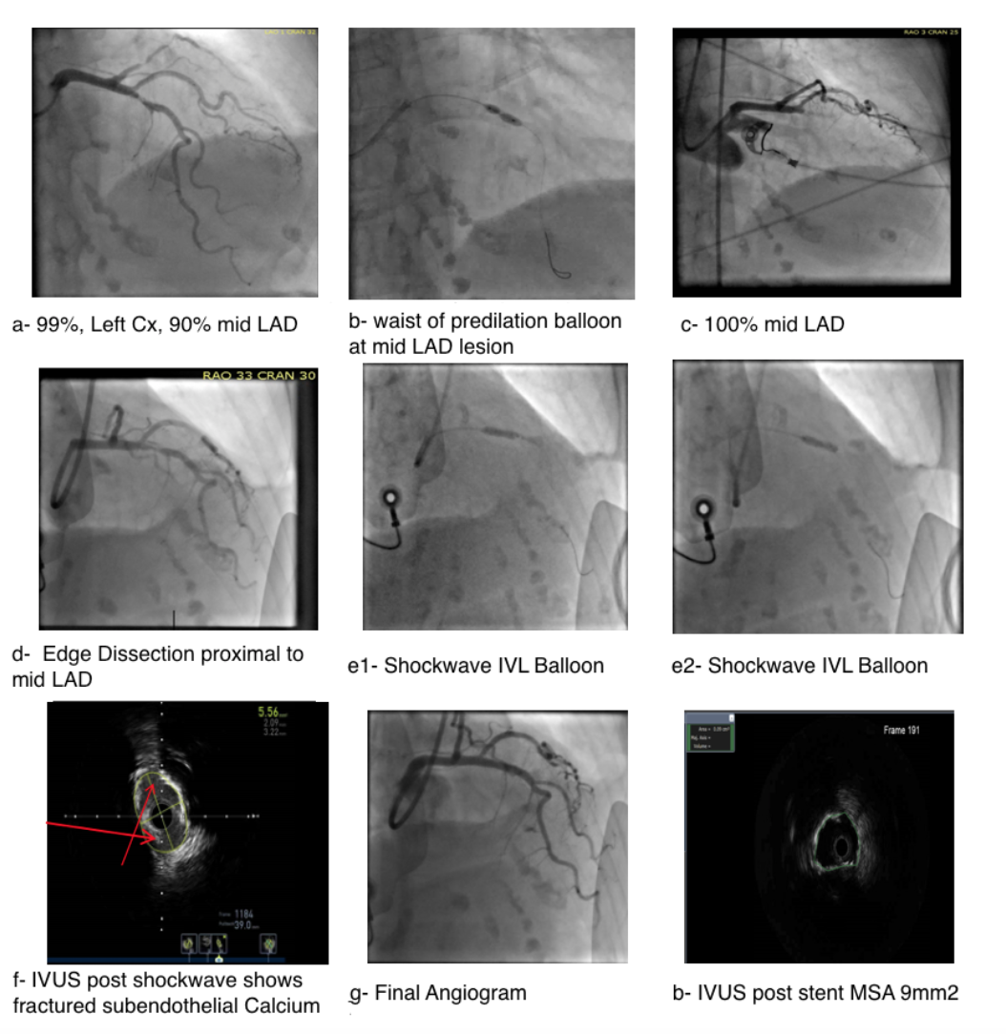

("ACS" OR "MI" OR "NSTE-ACS" OR "acute coronary syndrome") AND ("lithoplasty" OR "shockwave")

