Long-Term Outcomes after Single Versus Double Stenting for Unprotected Left Main Coronary Artery Bifurcation Lesions: An Updated Meta-Analysis

Introduction:
Comparisons between one- and two-stent strategies for unprotected distal left main coronary artery (ULMCA) bifurcation disease have yielded inconsistent results. We performed a systematic review and meta-analysis comparing single-stent (SS) versus double-stent (DS) implantation strategies for ULMCA bifurcation lesions.
Methods:
PubMed, Embase and Cochrane databases were searched for all studies comparing single versus double stenting for ULMCA bifurcation lesions. Primary outcome was long term all-cause mortality. Secondary outcomes included cardiac death, myocardial infarction (MI), target lesion/vessel revascularization (TLR/TVR) and stent thrombosis. Pooled odds ratios (OR) with their corresponding 95% confidence intervals were calculated using the Mantel-Haenszel random-effects model.
Results:
We included 15 observational? studies in our meta-analysis with a total of 8387 patients (SS group 4841, DS group 3546). Median follow up period was 3 years (IQR 2-5 years).
Primary outcomes were the same. There was no statistical difference in all-cause mortality (OR 1.16 [0.92-1.46]; p=0.21). Secondary outcomes showed no statistical significance in cardiac death (OR 1.26 [0.79-2.01]; p=0.34), MI (OR 0.89 [0.65-1.21]; p=0.46), and stent thrombosis (OR 1.04 [0.55-1.94]; p=0.91) between SS and DS groups. However, TLR/TVR rates were significantly lower in the SS group compared to the DS group. (OR 0.53 [0.39-0.73]; p<0.001)
Conclusion:
Our meta-analysis shows lower rates of TLR/TVR in patients undergoing single stent strategy compared to double-stent strategy. There is no difference in the rates of all-cause mortality, cardiac death, MI, or stent thrombosis between both strategies for bifurcation lesions of ULMCA disease.

- All Cause Death
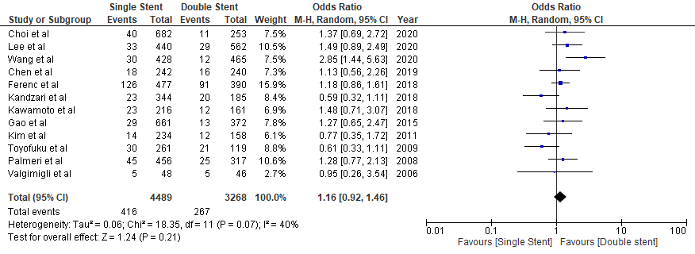

- Cardiac Death
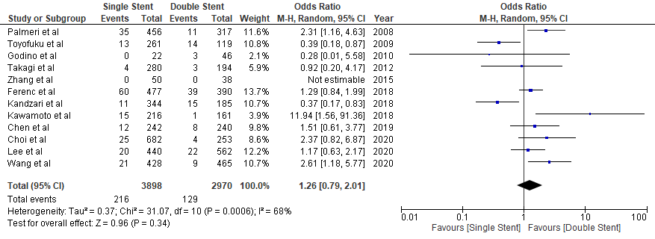

- Myocardial Infarction
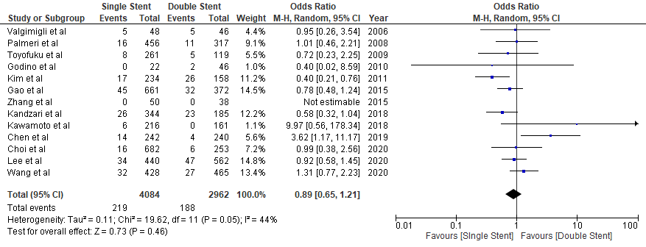

- TLR/TVR
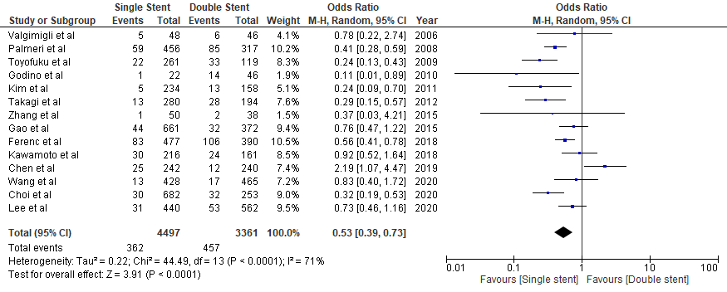
- In-stent Thrombosis
