THE FUTURE OF ACLS: IVABRADINE’S ROLE FOR THE TREATMENT OF VENTRICULAR ARRHYTHMIAS
Kristen N. Brown, MD, Lindsey Safley, PharmD, BCCP, Faris Khan, MD, MS
Division of Cardiovascular Medicine and Pharmaceutical Department, University of Nebraska Medical Center, Omaha, NE

Background
Ivabradine (IVA), an inhibitor of pacemaker “funny” current (I_{f}), is an attractive choice for the treatment of refractory ventricular arrhythmias (RVA) as it does not affect blood pressure or prolong QT interval. It’s efficacy in ventricular tachycardia (VT)/ventricular fibrillation (VF) has been demonstrated in several animal models and in human case reports with heart failure and catecholaminergic polymorphic ventricular tachycardia.^{1,2,3,4} It is hypothesized that I_{f} channels are upregulated in diseased myocardium.^{5,6,7} Furthermore, IVA has been shown to reduce VF propensity and time to onset of VF in the setting of acute myocardial infarction.³ We present a series of patients who required Ivabradine (IVA) for the treatment of RVA despite traditional medical therapies.
Methods
Three patients with RVA to standard therapies were identified and treated with IVA.
Results
Pt 1: 63M with ischemic cardiomyopathy admitted for refractory VF despite amiodarone, quinidine, and beta blocker. IVA 2.5mg BID was initiated with stabilization of the patient’s arrhythmia with resolution of RVA.
Pt 2: 61F admitted with cardiogenic shock secondary to Giant Cell Myocarditis complicated with VT/VF. IVA 2.5mg BID was initiated for persistent arrhythmia despite standard antiarrhythmic therapies with amiodarone and quinidine with resolution of RVA. IVA was up titrated to 5mg BID.
Pt 3: 58M with no significant medical history admitted with VF arrest. IVA 2.5mg BID was started for refractory VF despite medical therapy with amiodarone, quinidine, and procainamide with reduction of RVA.
All patients’ ventricular arrhythmias (Images A, C, E) were stabilized to sinus rhythm (Images B, D, F) with the addition of IVA to standard therapies (Figure 1).
Conclusion:
For RVA, IVA may be safe and necessary treatment option for rhythm stabilization and heart rate control. However, larger studies are required to assess the success of IVA in this population.
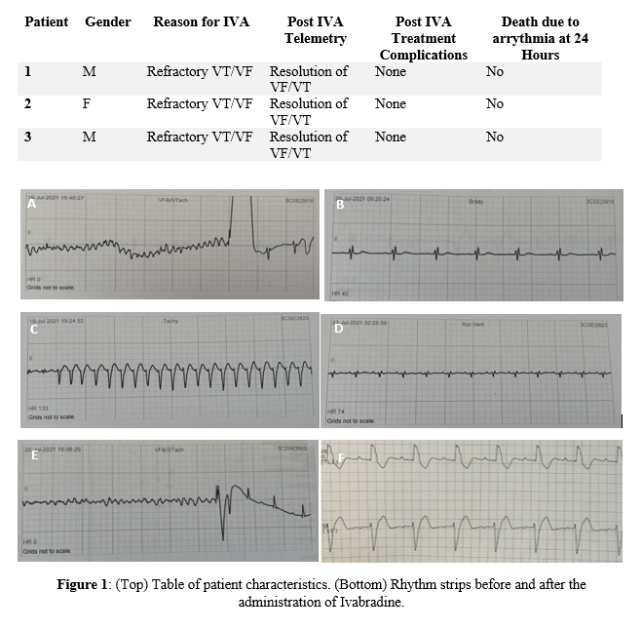
References:
- Mackiewicz U et al. Ivabradine protects against ventricular arrhythmias in acute myocardial infarction in the rat. J Cell Physiol. 2014 Jun;229(6):813-23.

- Marciszek M et al. Ivabradine is as effective as metoprolol in the prevention of ventricular arrhythmias in acute non-reperfused myocardial infarction in the rat. Sci Rep. 2020 Sep 14;10(1):15027.

- Vaillant F et al. Ivabradine induces an increase in ventricular fibrillation threshold during acute myocardial ischemia: an experimental study. J Cardiovasc Pharmacol. 2008 Dec;52(6):548-54. Yang M et al. Beneficial Effects of Ivabradine on Post-Resuscitation Myocardial Dysfunction in a Porcine Model of Cardiac Arrest. Shock. 2020 May;53(5):630-636.

- Kohli U, Aziz Z, Beaser AD, Nayak HM. Ventricular arrhythmia suppression with ivabradine in a patient with catecholaminergic polymorphic ventricular tachycardia refractory to nadolol, flecainide, and sympathectomy. Pacing Clin Electrophysiol. 2020 May;43(5):527-533.

- Ng FS et al. Selective heart rate reduction with ivabradine slows ischemia-induced electrophysiological changes and reduces ischemia-reperfusion-induced ventricular arrhythmias. J Mol Cell Cardiol. 2013 Jun; 59:67-75.

- Plotnikov AN, Bucchi A, Shlapakova I, Danilo P Jr, Brink PR, Robinson RB, Cohen IS, Rosen MR. HCN212-channel biological pacemakers manifesting ventricular tachyarrhythmias are responsive to treatment with I(f) blockade. Heart Rhythm. 2008 Feb;5(2):282-8.

- Marciszek M, Paterek A, Oknińska M, Zambrowska Z, Mackiewicz U, Mączewski M. Effect of ivabradine on cardiac arrhythmias: Antiarrhythmic or proarrhythmic? Heart Rhythm. 2021 Jul;18(7):1230-1238.

