ROTATIONAL ATHERECTOMY FOR CALCIFIED LESIONS DURING ST-SEGMENT ELEVATION MYOCARDIAL INFARCTION

Kristen N. Brown, MD, Aravdeep Jhand, MD, Yiannis Chatzizisis, MD, PhD, Andrew Goldsweig, MD, MS
Division of Cardiovascular Medicine, University of Nebraska Medical Center

Background: Rotational atherectomy (RA) has traditionally been contraindicated during ST elevation myocardial infarction (STEMI) due to fear of dissecting inflamed intima. To date, there are only a few isolated case reports. We present a series of RA required for calcified lesions during STEMI.

Case Series

Pt 1: 71M smoker admitted with right coronary STEMI. After predilation, intravascular ultrasound (IVUS) failed to pass a 360-degree calcified lesion. RA performed to allow stent passage. Final angiography revealed 0% residual stenosis.

Pt 2: 64M diabetic admitted with left anterior descending STEMI. After predilation, stent failed to pass 360-degree calcified lesion. RA performed to allow stent passage. Final angiography revealed 0% residual stenosis.

Pt 3: 61F with end-stage renal disease admitted with right coronary STEMI. After predilation, non-compliant balloon failed to pass 360-degree calcified lesion. RA performed to allow stent passage. Final angiography revealed 10% residual stenosis.

Decision-Making: In all 3 patients, equipment failed to pass, and IVUS demonstrated 360-degree calcification (Figure 1). Despite “official” contraindication in STEMI, RA was performed without complication.

Conclusion: For STEMI in severely calcified lesions, RA may be safe and necessary to deliver and expand stents. Larger studies are required to clarify the safety of RA in this population.

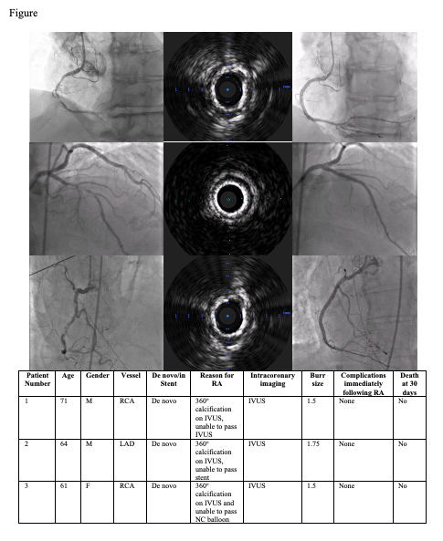
Figure 1: Representative pre-PCI angiograms, IVUS images showing 360-degree calcification, post-PCI angiograms along with a comparison table illustrating the similarities and differences of each individual patient.

