2021 Nebraska ACC abstract

Title: Electrocardiographic Findings Related to Propofol Infusion Syndrome
Authors: Cason Christensen, MD; John William Schleifer, MD; Lindsey Safley, PharmD;
Shane Tsai, MD
Affiliations: University of Nebraska Medical Center, Omaha, NE.
Background: Propofol is a commonly used sedative-hypnotic agent which can be associated with a rare life-threatening cardiac complication, propofol infusion syndrome (PRIS). We present a case including stepwise electrocardiographic (ECG) changes demonstrating a complex electrophysiologic pathophysiology consistent with PRIS.
Case: A 49-year-old male suffered head trauma requiring intubation and high-dose sedation for agitation with propofol infusion up to 65 mcg/kg/min. Progressive ECG changes and arrhythmia were noted: QRS widening with a right bundle branch block morphology, anterolateral ST segment elevation, sinusoidal waves, and non-sustained polymorphic ventricular tachycardia with brief periods of pulselessness. Left heart catheterization showed no angiographic coronary disease. Transthoracic echocardiogram demonstrated global hypokinesis with a left ventricular ejection fraction of 25-30%. Once PRIS was suspected and propofol discontinued, ECG changes normalized within 24 hours, and LVEF improved to 45-50% within 48 hours. The patient later developed oliguric acute kidney injury and hyperkalemia to a peak potassium of 6.4 mmol/L requiring hemodialysis. Importantly, these metabolic disturbances did not occur until after ECG changes had resolved; serum potassium at the time of the ECG changes was 5.2 mmol/L with a normal serum pH.
Discussion: PRIS is associated with Brugada-like pattern ECG changes. This case contrasts with classic medication-induced Brugada syndrome in that the Brugada pattern did not emerge until after ventricular arrythmias had occurred, and coved ST-segment elevation was most predominant in the inferior leads. These findings suggest that the pathogenesis of PRIS is more complex than mere sodium channel blockade. Due to poor and often late clinical recognition, these serial ECG changes have not been previously described.
Conclusion: PRIS should be suspected in any patient with QRS widening while receiving a propofol infusion. Prompt recognition and cessation of propofol may prevent cardiovascular complications including mortality.

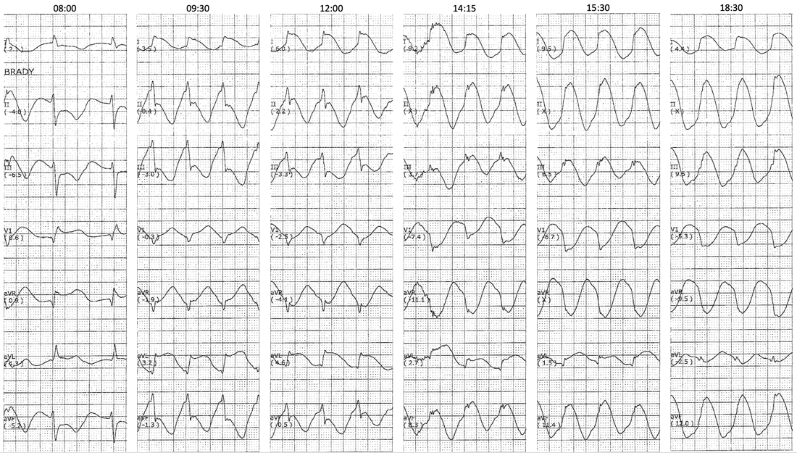
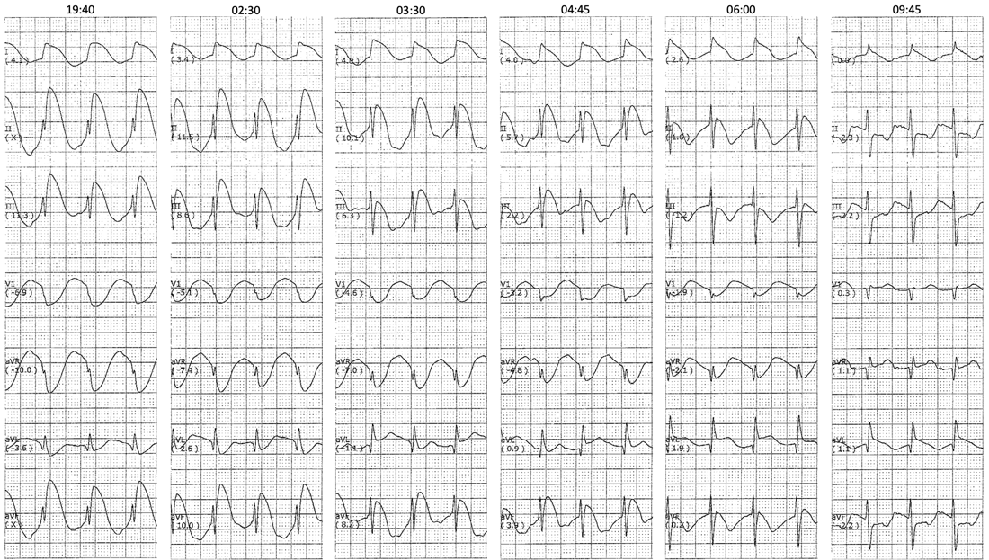
Figure: Serial ECG changes seen in PRIS. Propofol was discontinued shortly after the initial rhythm strip.

