Plasma Trimethylamine-N-oxide and Progression of Coronary Artery calcium in MESA (Multi-Ethnic Study of Atherosclerosis)
Background
Gut microbial metabolite trimethylamine N-oxide (TMAO) has been implicated in cardiovascular disease risk. This study examined the relationship of plasma TMAO with coronary artery calcium (CAC).
Methods
We studied 3,298 participants aged 45-84 years from the MESA (Multi-Ethnic Study of Atherosclerosis) study, with available baseline (Exam 1) and follow-up (Exam 5) CAC scans ~10 years apart. Association of baseline TMAO with incident CAC (CAC=0 at baseline and any increase at follow up) and annualized CAC progression (for patients with baseline CAC>0) was examined using multivariable logistic and log-normal regression.
Results
Individuals in the highest TMAO quartile were notably older, were more often male, caucasian race and had a higher prevalence of hypertension, diabetes, and metabolic syndrome. The CAC scores at baseline and during follow up increased progressively across the TMAO quartiles. Of those free of CAC at Exam 1 (n=1844) , 46.0% (n=849) developed detectable CAC at follow up. On multivariable analysis, TMAO was not independently associated with CAC incidence (OR 0.89; 95% CI: 0.66–1.18, p = 0.414; for the 4th vs 1st quartile) or CAC progression 13.9%% (95% CI: -5.4% to 37%; P = 0.169; for the 4th vs 1st quartile)
Conclusions
In this population-based study of a racially and ethnically diverse cohort without clinical evidence of CVD at baseline, no significant independent association was seen between TMAO and CAC incidence or progression after adjusting for other major risk factors and potential confounders.

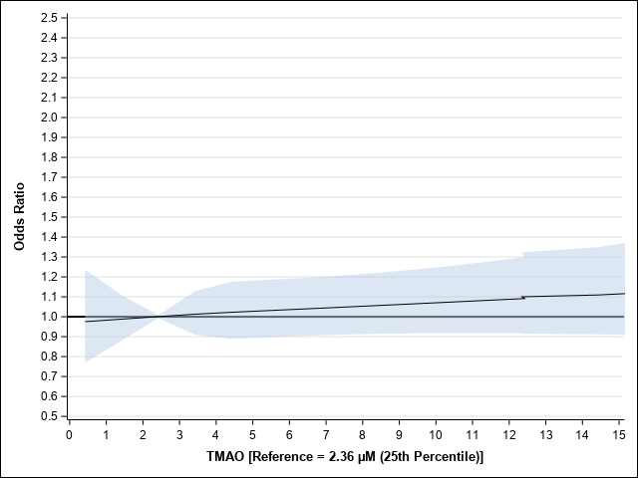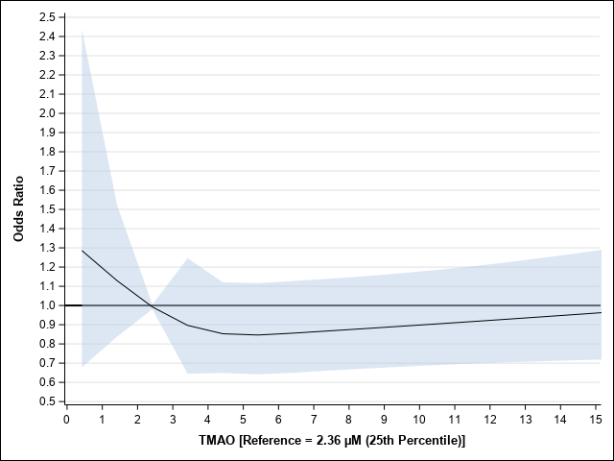
1B
1A
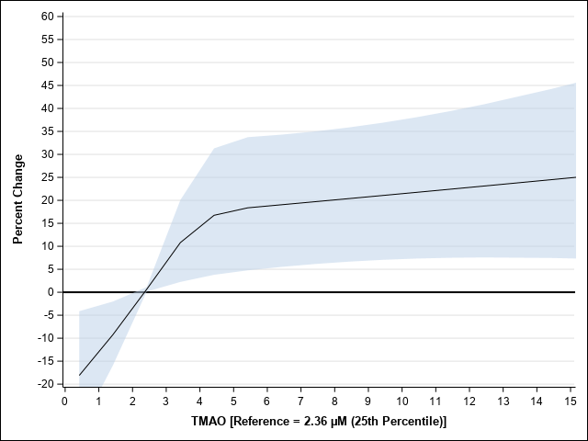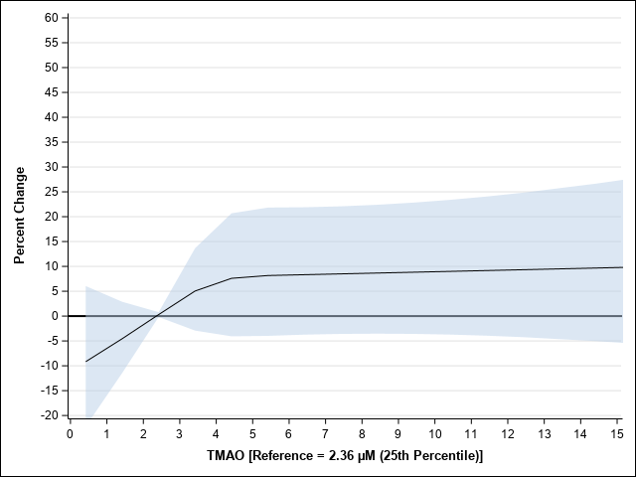
1D
1C
Figure 1A - Unadjusted Incidence_Plot of Odds Ratios for Comparisons of TMAO Values to Median (2.36 µM) via Restricted Cubic Spline
Figure 1B - Fully Adjusted Incidence Plot of Odds Ratios for Comparisons of TMAO Values to Median (2.36 µM) via Restricted Cubic Spline
Figure 1C - Unadjusted Progression_Plot of Percent Change for Comparisons of TMAO Values to Median (2.36 µM) via Restricted Cubic Spline
Figure 1D - Fully Adjusted Progression_Plot of Percent Change for Comparisons of TMAO Values to Median (2.36 µM) via Restricted Cubic Spline

